**SYNOPSIS**

**Report on**

**ENVIRONMENTAL SURVEY PORTAL**

**by**

Oorja Rajoria 2200290140103

**Session:2023-2024 (IV Semester)**

Under the supervision of

**Prof. Dr. Amit Kumar Assistant Professor**

### KIET Group of Institutions, Delhi-NCR, Ghaziabad



### Department Of Computer Applications

**KIET GROUP OF INSTITUTIONS, DELHI-NCR, GHAZIABAD-201206**

(April - 2024)

**ABSTRACT**

In response to the pressing need for comprehensive environmental monitoring and management, this project proposes the development of an Environmental Survey Portal (ESP). The ESP aims to provide a user-friendly platform for conducting environmental surveys, gathering data, and facilitating informed decision-making processes. Key features of the proposed ESP include customizable survey templates, real-time data collection capabilities, interactive mapping functionalities. The portal will facilitate the collection of diverse data types, including qualitative observations, quantitative measurements, and multimedia content.

In conclusion, the Environmental Survey Portal represents a timely and innovative solution to the challenges of environmental monitoring and management. By empowering stakeholders with accessible tools for data collection, analysis, and decision-making, it has the potential to contribute significantly to environmental sustainability efforts and facilitate evidence-based policy formulation and implementation.

**TABLE OF CONTENTS**

Page Number

1. Introduction 4
2. Literature Review 6
3. Project / Research Objective 8
4. Project Flow/ Research Methodology 10
5. Project / Research Outcome 12
6. Proposed Time Duration 15

References/ Bibliography

**Introduction**

In recent years, escalating concerns over environmental degradation, climate change, and biodiversity loss have underscored the urgent need for effective environmental monitoring and management strategies. Robust data collection and analysis are fundamental to understanding the complex interactions between human activities and the environment, identifying emerging environmental threats, and formulating evidence-based policies to address them. However, traditional methods of data collection often suffer from limitations such as high cost, limited spatial coverage, and time-consuming processes.

To address these challenges, this project proposes the development of an Environmental Survey Portal (ESP) as a novel solution to facilitate comprehensive environmental surveying and data collection. The ESP aims to harness the power of modern technologies, including web-based platforms and geographical information systems (GIS), to streamline the process of conducting environmental surveys, gathering data, and analyzing results.

By providing a user-friendly interface and customizable survey templates, the ESP will empower a wide range of stakeholders, including environmental scientists, policymakers, conservationists, and community members, to participate in data collection efforts tailored to their specific interests and expertise. Real-time data collection capabilities will enable timely monitoring of environmental changes and the identification of emerging threats, while interactive mapping functionalities will facilitate the visualization of survey results in a spatial context.

Through the integration of GIS and advanced data analytics tools, the ESP will enable users to perform spatial analysis, identify patterns, and derive actionable insights from survey data. Furthermore, the portal will support data aggregation and synthesis, allowing for the generation of comprehensive reports and informative visualizations to inform decision-making processes at various levels.

The proposed project represents a timely and innovative approach to addressing the pressing challenges of environmental monitoring and management. By providing stakeholders with accessible tools for data collection, analysis, and decision-making, the ESP has the potential to enhance our understanding of environmental dynamics, foster collaboration among diverse stakeholders, and support informed decision-making towards achieving environmental sustainability goals.

**Literature Review**

Environmental survey projects play a crucial role in understanding and mitigating environmental challenges by gathering data, insights, and feedback from various stakeholders. In recent years, the integration of JSP (JavaServer Pages), Servlets, and MySQL has emerged as a powerful approach for developing interactive and data-driven survey applications. This literature review aims to explore existing research and practices related to environmental survey projects involving students, faculty, and administrators, with a focus on the use of JSP, Servlet, and MySQL technologies.

1. Importance of Environmental Survey Projects:

Environmental survey projects serve as valuable tools for assessing environmental issues, monitoring changes, and informing decision-making processes. These projects facilitate the engagement of stakeholders, including students, faculty, and administrators, in data collection and analysis, fostering a collaborative approach to environmental stewardship.

2. Role of Technology in Environmental Surveys:

The integration of JSP, Servlet, and MySQL technologies offers several advantages for environmental survey projects. JSP enables the creation of dynamic web pages, allowing for interactive survey interfaces accessible across different devices. Servlets facilitate server-side processing, enabling the handling of user requests and data manipulation. MySQL, a popular relational database management system, provides robust data storage and retrieval capabilities, essential for managing survey data efficiently.

3. Engaging Students in Environmental Surveys:

Several studies have demonstrated the effectiveness of involving students in environmental survey projects. Engaging students in hands-on data collection activities not only enhances their understanding of environmental issues but also fosters a sense of environmental responsibility and civic engagement. The use of technology such as JSP, Servlets, and MySQL can make survey participation more accessible and engaging for students, enabling real-time data visualization and analysis.

4. Collaboration with Faculty Members:

Faculty members play a vital role in guiding and supervising environmental survey projects. Their expertise contributes to the design of survey instruments, data analysis methodologies, and interpretation of results. Integrating JSP, Servlet, and MySQL technologies into survey projects provides faculty members with powerful tools for designing interactive surveys, managing data, and facilitating collaborative research efforts with students and administrators.

5. Administrative Support and Institutional Impact:

Administrative support is essential for the successful implementation of environmental survey projects within educational institutions. Administrators can provide resources, logistical support, and institutional endorsement, enhancing the credibility and impact of survey initiatives. By leveraging technology, such as JSP, Servlets, and MySQL, administrators can streamline survey administration processes, automate data management tasks, and facilitate communication among stakeholders, thereby maximizing the effectiveness of environmental survey projects.

Conclusion:

The integration of JSP, Servlet, and MySQL technologies offers a powerful platform for implementing environmental survey projects involving students, faculty, and administrators. By leveraging these technologies, educational institutions can engage stakeholders more effectively, collect and analyze environmental data efficiently, and promote collaborative efforts towards addressing environmental challenges. Future research in this area should focus on evaluating the impact of technology-enhanced survey projects on environmental awareness, behavior change, and institutional sustainability efforts. Additionally, studies exploring the scalability, usability, and accessibility of JSP, Servlet, and MySQL-based survey applications can further advance the field of environmental survey research.

**Project Objective**

The primary objective of the EcoSurvey project is to develop an integrated environmental survey platform using JSP, Servlet, and MySQL technologies to facilitate data collection, analysis, and stakeholder engagement. The project aims to address the following objectives:

1. Design and Development:

- Develop a user-friendly web interface using JSP for creating and administering environmental surveys.

- Implement Servlets to handle user requests, process survey data, and interact with the MySQL database.

- Design a relational database schema using MySQL to store survey questions, responses, user information, and administrative settings.

2. Stakeholder Engagement:

- Engage students, faculty, and administrators in the design and implementation of environmental survey projects.

- Provide stakeholders with access to the survey platform to participate in data collection activities, view survey results, and collaborate on research initiatives.

3. Data Collection and Analysis:

- Enable real-time data collection through the web-based survey interface, allowing respondents to provide feedback on environmental issues and initiatives.

- Implement data validation and integrity checks to ensure the accuracy and reliability of survey responses.

- Incorporate data analysis features to generate descriptive statistics, visualizations, and reports based on survey data.

4. Accessibility and Scalability:

- Ensure the accessibility of the survey platform across different devices and web browsers, accommodating the diverse needs of stakeholders.

- Design the platform to be scalable, allowing for the addition of new surveys, users, and features as the project expands and evolves.

5. Security and Privacy:

- Implement robust security measures to protect sensitive survey data, including encryption of user credentials, secure transmission of data over HTTPS, and role-based access control.

- Ensure compliance with relevant data privacy regulations and institutional policies to safeguard the confidentiality and privacy of survey participants.

6. Evaluation and Feedback:

- Conduct usability testing and gather feedback from stakeholders to identify areas for improvement and refinement of the survey platform.

- Iterate on the design and functionality of the platform based on user input and evaluation results to enhance user satisfaction and engagement.

By achieving these objectives, the EcoSurvey project aims to empower stakeholders to actively participate in environmental survey initiatives, foster collaboration and knowledge sharing, and contribute to informed decision-making processes for environmental stewardship and sustainability.

**Research Methodology**

1. Development Approach:

The research methodology for the environmental survey project involves a systematic development approach focusing on the integration of JSP, Servlet, and MySQL technologies. The project follows the principles of agile software development to ensure flexibility, adaptability, and iterative improvement throughout the development process.

2. Requirement Analysis:

Conduct comprehensive requirement analysis through stakeholder consultations, literature review, and environmental survey best practices. Identify key functionalities, user roles, data requirements, and system constraints to inform the design and development of the survey platform.

3. System Design:

Develop a detailed system architecture and design based on the identified requirements and technology stack. Define the structure of the relational database using MySQL, design user interfaces using JSP, and outline the server-side logic and request handling using Servlets. Pay particular attention to scalability, usability, security, and data integrity aspects during the design phase.

4. Prototyping and Iterative Development:

Begin the development process with the creation of prototypes to validate design concepts and gather feedback from stakeholders. Implement core features incrementally, following an iterative development approach. Continuously test and refine the system based on user feedback, addressing usability issues, performance bottlenecks, and functionality gaps as they arise.

5. Data Collection and Integration:

Integrate data collection mechanisms into the survey platform, allowing users to create, distribute, and respond to environmental surveys through the web interface. Implement functionality for capturing survey responses, storing data in the MySQL database, and performing necessary validation and processing tasks using Servlets.

6. Testing and Quality Assurance:

Conduct rigorous testing at each stage of the development process to ensure the reliability, functionality, and performance of the survey platform. Perform unit testing, integration testing, and system testing to identify and address defects, inconsistencies, and usability issues. Utilize automated testing tools and manual testing procedures to validate system behavior across different environments and usage scenarios.

7. Deployment and User Training:

Prepare for the deployment of the survey platform by configuring hosting environments, setting up databases, and deploying application artifacts. Provide user training and documentation to familiarize stakeholders with the functionality, features, and usage of the survey platform. Ensure smooth transition and adoption of the system by addressing user concerns and providing ongoing support and assistance as needed.

8. Evaluation and Feedback:

Evaluate the effectiveness and impact of the survey platform through user feedback, surveys, and performance metrics. Collect qualitative and quantitative data on user satisfaction, system usability, data quality, and stakeholder engagement. Use evaluation findings to identify areas for improvement, refine system functionality, and inform future development iterations.

By following this research methodology, the environmental survey project aims to deliver a robust, user-friendly, and effective survey platform that leverages JSP, Servlet, and MySQL technologies to facilitate stakeholder engagement, data collection, and environmental research initiatives.

**Project Outcome**

The EcoSurvey platform represents a comprehensive and integrated solution for environmental survey initiatives within our institution. Leveraging JSP, Servlet, and MySQL technologies, EcoSurvey provides a user-friendly, scalable, and secure environment for conducting environmental surveys, engaging stakeholders, and promoting collaborative research efforts among administrators, faculty, and students.

Key Features:

1. User-Friendly Interface:

EcoSurvey offers an intuitive web-based interface accessible to administrators, faculty, and students alike. Users can easily create, distribute, and respond to environmental surveys, with customizable survey templates and interactive question formats enhancing user engagement.

2. Role-Based Access Control:

The platform implements role-based access control mechanisms to ensure data security and privacy. Administrators have full control over survey creation, management, and analysis, while faculty members and students are granted appropriate permissions based on their roles and responsibilities.

3. Dynamic Survey Creation:

EcoSurvey enables administrators, faculty, and students to create dynamic surveys tailored to specific environmental topics, research objectives, and target audiences. Users can design surveys with various question types, including multiple choice, open-ended, and Likert scale questions, to gather diverse perspectives and insights.

4. Real-Time Data Collection and Analysis:

Survey responses are collected in real-time and stored securely in the MySQL database, allowing for immediate data analysis and visualization. EcoSurvey offers built-in analytics tools for generating descriptive statistics, graphical representations, and summary reports, empowering users to interpret survey findings and make informed decisions.

5. Collaboration and Communication:

The platform fosters collaboration and communication among stakeholders by facilitating data sharing, discussion forums, and research collaborations. Faculty members can initiate research projects, invite student participation, and collaborate with administrators to address pressing environmental issues and opportunities.

6. Accessibility and Scalability:

EcoSurvey is designed to be accessible across different devices and web browsers, accommodating the diverse needs and preferences of users. The platform is scalable, allowing for the addition of new surveys, users, and features as the scope and complexity of environmental survey projects evolve over time.

7. Training and Support:

Comprehensive user training materials and support resources are provided to administrators, faculty, and students to ensure successful adoption and utilization of the EcoSurvey platform. Technical assistance, troubleshooting guides, and online tutorials are available to address user queries and facilitate seamless interaction with the system.

Overall, the EcoSurvey platform serves as a valuable tool for promoting environmental awareness, engagement, and research excellence within our institution. By harnessing the power of JSP, Servlet, and MySQL technologies, EcoSurvey empowers administrators, faculty, and students to collaborate effectively, collect meaningful data, and drive positive environmental change at local, regional, and global levels.

**Proposed Time Duration**

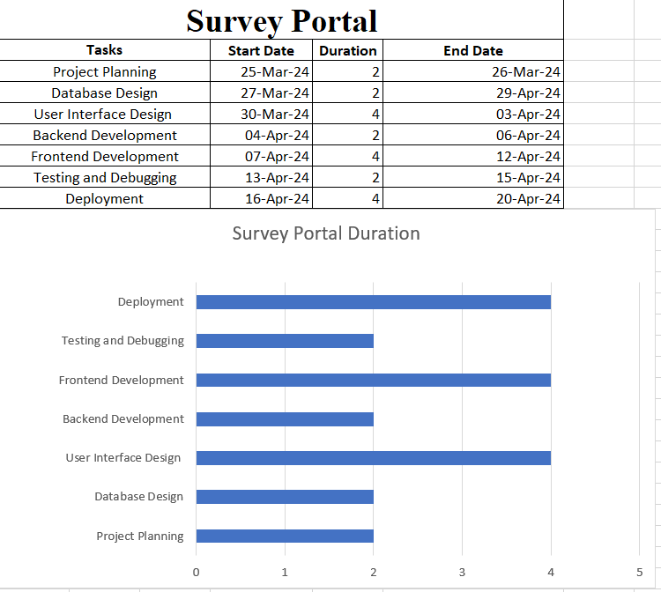

**REFERENCES/ Bibliography**

1. <https://www.youtube.com/watch?v=X88tvHZKmI0&list=PLQTYNpk8jwk1jj3T9K_pygQG19bkpYIVG>
2. <https://www.youtube.com/watch?v=WkKT5M-ABnY&list=PLlhM4lkb2sEiiEAP0uSFXiFY8KdXPnN0f>
3. <https://www.youtube.com/results?search_query=mysql+workbench>
4. <https://www.youtube.com/watch?v=fUK94jOFwBc>